EXPT 4.2: Configure SMTP and FTP protocols using Packet Tracer

Objective:
(ii) To configure and test file transfer operations between a client and a server using the FTP protocol and verify successful file upload and download.
Software/Apparatus required:
(i) Cisco Packet Tracer
(ii) End Devices (PCs)
(iii) Switches
(iv) Copper Straight-through Cable / Automatic Cable Selector
(v) Routers
(vi) Server (Email server or FTP Server)
Procedure:
Objective 2: FTP Protocol
1. Create the network topology using PCs, switches, a router, and an FTP server.
2. Configure the network settings and verify connectivity between the client PC and the FTP server.
3. Enable the FTP service on the server and create the required files.
4. Open the Command Prompt on the client PC and connect to the FTP server using ftp <Server_IP_Address>.
5. Display the files available on the server using dir.
6. Download a file from the server using get sample.txt.
7. Verify the downloaded file using dir.
8. Upload a file from the client PC to the server using put report.txt.
9. Display the updated file list using dir.
10. Close the FTP session using quit.
11. Verify that the file transfer operation was completed successfully.
Network Diagram
Objective 2: FTP Protocol
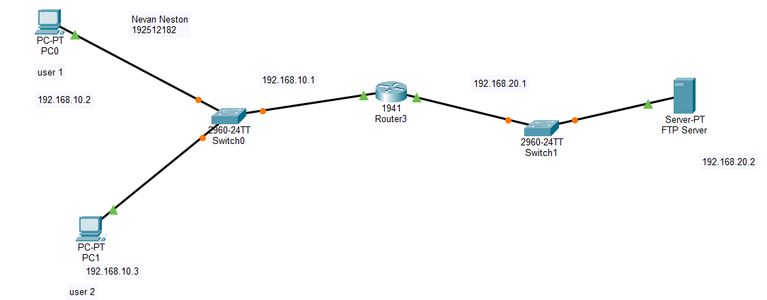

OUTPUT:
Objective 2: FTP protocol
Username 1 | Password 1 | Username 2 | Password 2 | File shared
vishnu | 12345 | vishnu | 12345 | Self.txt

Result:
Objective 2: FTP Protocol
(ii) File transfer was successfully established, and files were uploaded to and downloaded from the FTP server using the FTP protocol.

